NOTE! The following questionnaire is designed to allow an individual DSE user to assess their workstation/s. Where a user has answered ‘No’ to any question in Part B or provided details of any health effects in Part C, the employer should investigate and assess further and/or make any workstation adjustments, if necessary.

Before completing this questionnaire, please refer to figure 1 for guidance on DSE set up and seating position.

NAME OF COMPUTER USER:
DEPARTMENT:
LOCATION OF WORKSTATION:
DATE OF ASSESSMENT:

PART A - GENERAL INFORMATION

HOW MUCH TIME IS SPENT ON THE DISPLAY SCREEN PER DAY? (HOURS/MINS)

PART B - COMPUTER / DEVICE & SCREEN:

SCREEN & DISPLAY: | YES | NO | N/A
Are the characters on screen clear and easy to read?
Is the image on screen free from flicker and movement?
Are brightness and contrast controls adjustable?
Can the screen be swivelled and tilted?
Is the screen clean and free from glare and reflection?
Is the top of the computer screen at or just below eye level?
KEYBOARD | YES | NO | N/A
Is the keyboard separate from the screen?
Can the keyboard be tilted?
Is the keyboard easy to reach?
Is there adequate space in front of the keyboard to rest your hands and wrists?
Is the keyboard free from glare?
Are all characters clear and easy to read?
MOUSE OR OTHER POINTING DEVICE | YES | NO | N/A
Is the device comfortable to use?
Is the device suitable for right or left handed persons?
Can the device settings be adjusted to your personal preferences?

DESK: | YES | NO | N/A
Is there adequate free space on the desk for all your work?
Is the layout of the work surface sufficient for all necessary equipment? e.g. computer, keyboard, telephone, printer etc.
Is all workstation equipment easy to reach?
Is there adequate space to adjust the position of the equipment in order to adopt a comfortable work posture?
Are work surfaces in a good and stable condition?
Is there adequate legroom under the desk?
Is the space under the desk clear of obstructions?
Are surfaces free from glare and reflections?
CHAIR | YES | NO | N/A
Is your chair stable? i.e. does it have five moveable castors?
Has your seat got suitable lumbar support?
Can the height of the seat be adjusted?
Can the height and tilt angle of the backrest be adjusted?
Does the seat rotate easily?
Are the seat arms detachable, if required?
ANCILLARY EQUIPMENT | YES | NO | N/A
Can you sit comfortably without the aid of a footrest?
Has a stable and adjustable document holder been provided (if needed)?
If you are required to simultaneously use the telephone and computer do you use a hands free speakerphone or a headset?
Can your feet touch the floor or footrest?
If a footrest is provided, can it be adjusted?

NOISE AND VIBRATION | YES | NO | N/A
Are the temperature and humidity levels comfortable?
Is there sufficient ventilation that does not cause discomfort from draughts?
Are noise levels comfortable?
Is there sufficient workspace?
Is the lighting, including any specific task lighting, sufficient?
Are you able to control the amount of natural light with blinds or curtains?

TASK DESIGN AND SOFTWARE | YES | NO | N/A
Is software suitable for the tasks?
Have you been trained to use the software?
Are tasks organised to avoid long periods of intensive activity?
Can you control the tasks? e.g. speed of recording data etc.

GENERAL SAFETY | YES | NO | N/A
Have you been informed of your entitlement to free eye and eye sight tests?
Are all electrical cables etc. in good condition and properly connected?
Are cables secure and tidy?
Is all equipment, furniture etc. safely positioned?
Do you have adequate rest breaks?
Are you able to take breaks at your discretion?
Can you leave your workstation during breaks?

PART C – HEALTH & ADDITIONAL CONSIDERATIONS:

COMMENTS:
Please include any comments that you would like to make regarding your workstation or its local environment. Also note any adverse health effects experienced, e.g. aches, pains, sensory loss (‘tingling’ or ‘pins and needles’) in your neck, back, shoulders, upper limbs, restricted joint movements or grip.
USER’S SIGNATURE: |  | DATE:

ASSESSOR’S COMMENTS, INCLUDING DETAILS OF ANY ACTION TO BE TAKEN.
ASSESSOR’S NAME: |  | SIGNATURE:
DATE: |  | DATE OF RE-ASSESSMENT:

FIGURE 1. SEATING AND POSTURE FOR TYPICAL OFFICE TASKS

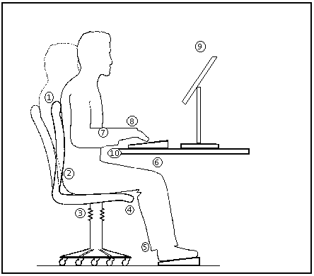

1. | Seat back adjustability.
2. | Good lumbar support.
3. | Seat height adjustment.
4. | No excess pressure on underside of thighs and backs of knees.
5. | Footrest, if needed.
6. | Space for postural change, no obstacles under desk.
7. | Forearms approximately horizontal.
8. | Minimal extension, flexion, or deviation of wrists.
9. | Screen height and angle should allow comfortable head position.
10. | Space in front of keyboard to support hands/wrists during pauses in keying.



